1-

-----------------------------------------------------------------------------------------
2-

-----------------------------------------------------------

3-


---------------------------------------------------------
4-


------------------------------------------------------------

5-


---------------------------------------------------------

6-

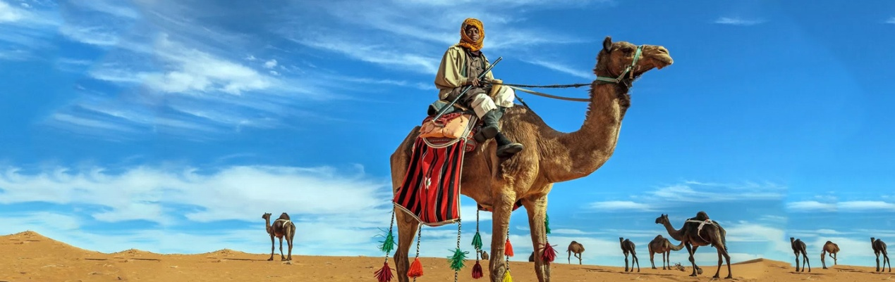

---------------------------------------------------------
7-



---------------------------------------------------------

7-

